- Which of the following quantities has a unit that can be expressed in terms of just two different SI base units?

  - Area
B. Charge
C. Current
D. Force

2. Which one of the following quantities cannot be measured in joules?

A. force x displacement B. pressure x volume
C. stress x strain D. mass x length x acceleration

3. The power loss P in a resistor is calculated using the formula P = V²/R.
The uncertainty in the potential difference is 4 % and the uncertainty in the resistance is 3 %.
What is the uncertainty in P?

A. 11 % B. 13 % C. 9 % D. 5 %

4. A signal generator (a source of electrical oscillations) is connected to a cathode-
ray oscilloscope which has a screen 7.0 cm wide.

The diagram shows the waveform on the screen when the calibrated time-base is
set to 10 μs/cm.

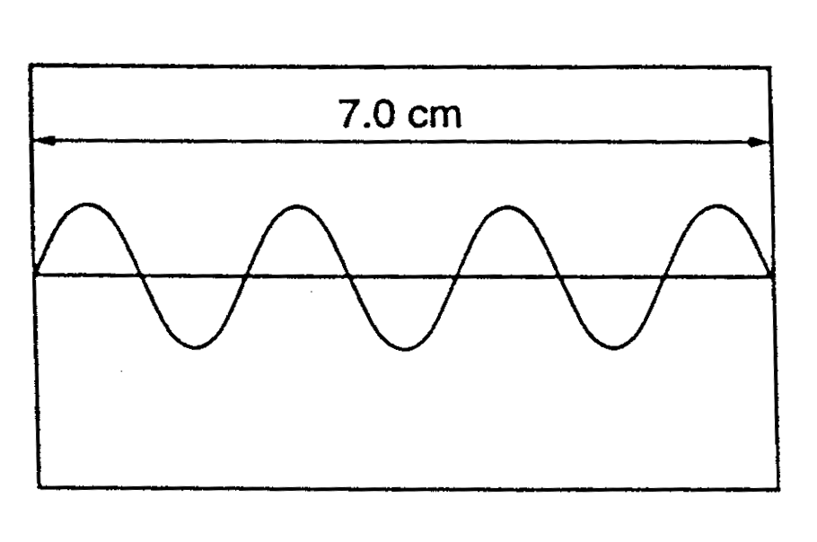
What is the period of the electrical oscillation?

A. 10 μs B. 20 μs C. 40 μs D. 100 μs

5. A parachutist steps from an aircraft, falls without air resistance for 2 s and then
opens her parachute.

Which graph best represents the variation with time t of her vertical acceleration
a during the first 5 s of her descent?
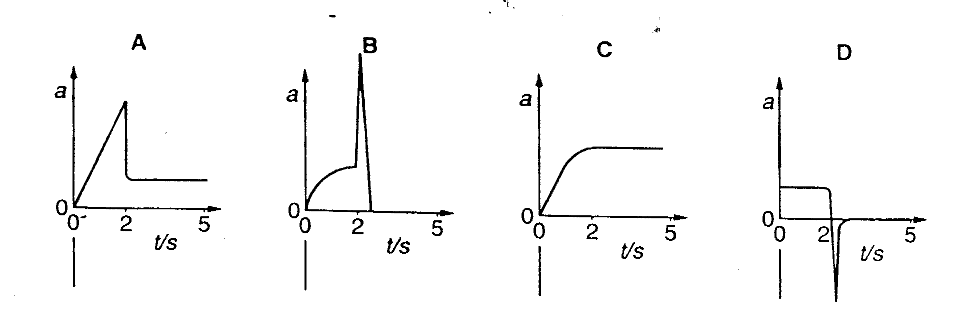

6. A neutron is in head – on elastic collision with a stationary nitrogen nucleus. The mass of a nitrogen nucleus is 14 times that of a neutron.
The neutron’s velocity after the collision is

- Less in magnitude than its initial velocity.
- Less in magnitude than the final velocity of the nitrogen atom
- Equal in magnitude to its initial velocity but in the opposite direction.
- Greater in magnitude than its initial velocity.

7. When a force of 8 N acts on a mass of 2 kg for a time 2 s, what is the rate of change of momentum?

- 1 kg ms⁻²
- 4 kg ms⁻²
- 6 kg ms⁻²
- 8 kg ms⁻²

[Turn Over
8. A quantity X is measured many times. A graph is plotted showing the number n
of times a particular value of X is obtained. X has a true value X₀
Which graph could be obtained if the measurement of X has a large systematic
error but a small random error?
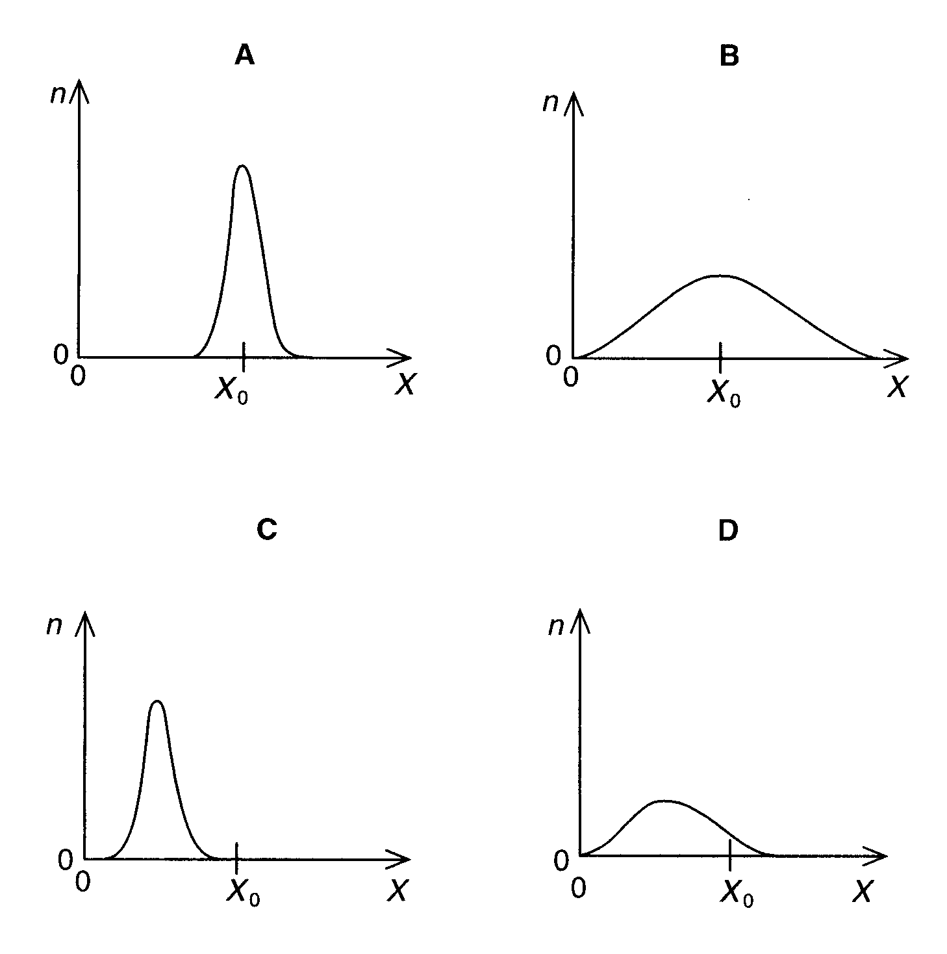

9. A new design of car is described as being capable of braking from 24 ms⁻¹ to
rest in 6.0 s. The brakes provide a constant retarding force.

What is the distance the car travels when brought to rest from a speed of 24 ms⁻¹ ?

A. 72 m B. 78 m C. 152 m D. 40 m

10. The graph relates to the motion of a falling body.

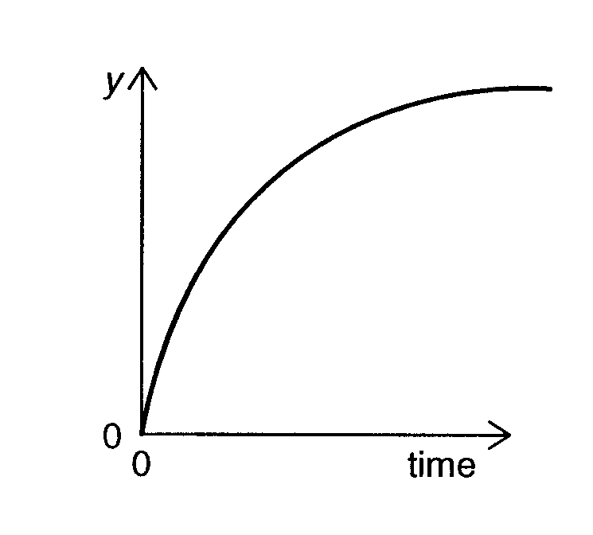

Which is a correct description of the graph?

A. y is the distance and air resistance is negligible

B. y is the distance and air resistance is not negligible

C. y is speed and air resistance is not negligible

D. y is speed and air resistance is negligible

11. A body of mass m travelling with speed 4u collides with and sticks to a body
of mass 4m traveling in the same direction with speed u.

4u u

4m
m

What is the speed with which the two travel after sticking together?

A. 2u/5 B. 4u/5 C. 6u/5 D. 8u/5

[Turn Over
12. A box of mass 6.0 kg rests on a horizontal, rough surface. A string attached to
the box passes over a smooth pulley and supports a 2.0 kg mass at its other end. 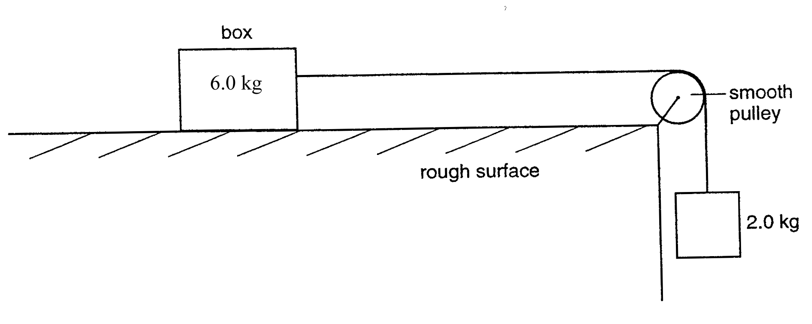
When the box is released, a friction force of 6.0 N acts on it.
What is the acceleration of the box?

A. 1.4 ms⁻² B. 1.7 ms⁻² C. 2.0 ms⁻² D. 2.5 ms⁻²

13. A heavy uniform plank of length L is supported by two forces F₁ and F₂ at
points distant L/4 and L/8 from its ends, as shown.

L

L/4 L/8

F₁ F₂

What is the value of F₁/F₂ ?

A. 2/5 B. 3/5 C. 2/3 D. 3/2
14. A child (mass m) sits on a car seat which is accelerating horizontally at 0.80 g
(where g is the acceleration of free fall).

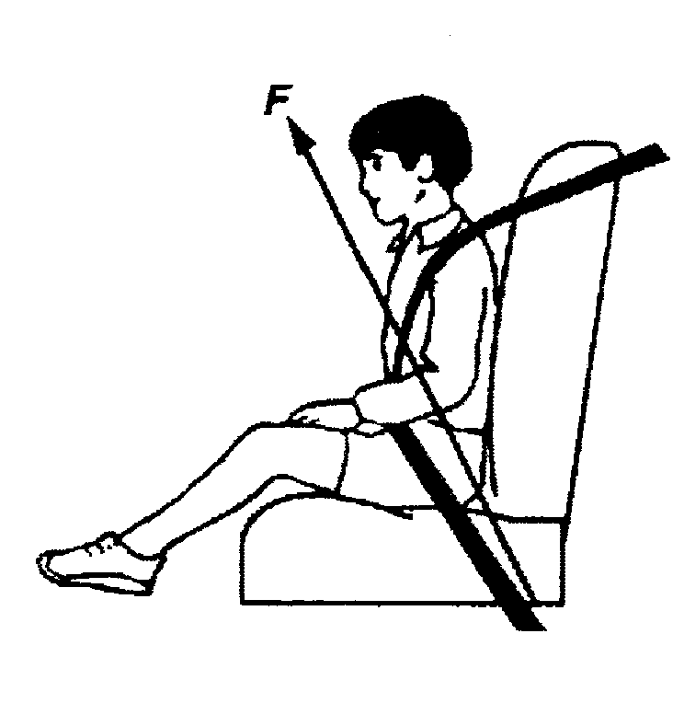
What is the magnitude of the total force F exerted by the car seat on the child?

A. 0.80 mg B. 1.0 mg C. 1.3 mg D. 1.8 mg

15. A ruler of length 0.50 m is pivoted at its center. Equal and opposite forces of magnitude 4.0 N are applied to the ends of the ruler, creating a couple as shown.
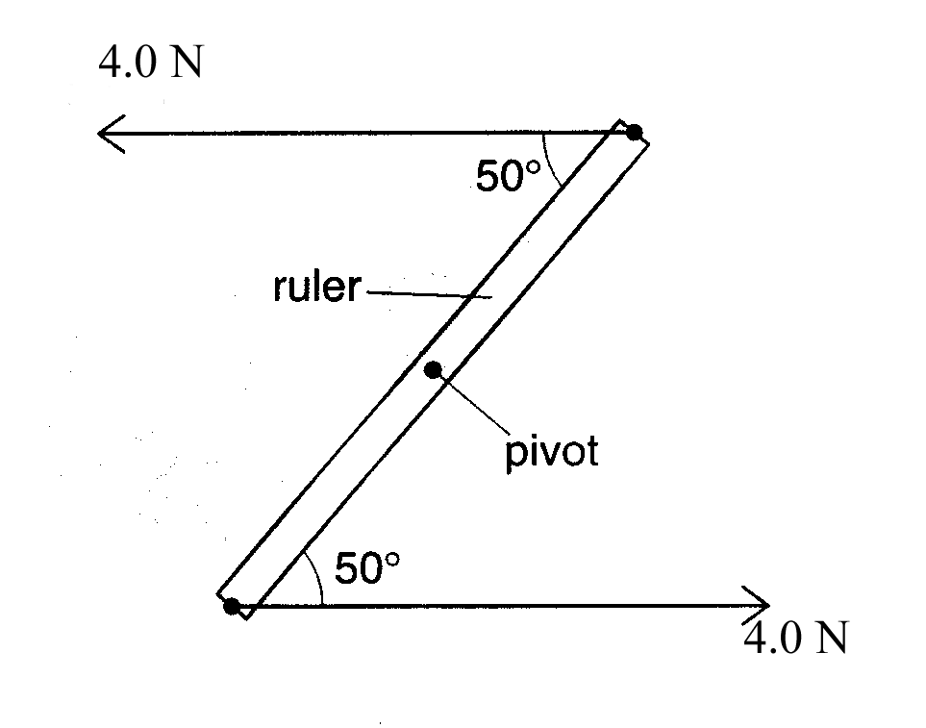
What is the magnitude of the torque of the couple on the ruler when it is in the position shown?

A. 0.53 B. 1.53 C. 0.83 D. 1.93

[Turn Over

16. A cylindrical block of wood has a cross-sectional area A and weight W. It is
totally immersed in water with its axis vertical. The block experiences
pressures P_{t} and P_{b} at its top and bottom surfaces respectively.

Which of the following expressions is equal to the upthrust of the block?

A. (P_{b} – P_{t}) A + W

B. (P_{b} – P_{t}) A

C. (P_{b} – P_{t}) A - W

D. (P_{b} – P_{t})

17. An object of mass m passes a point X with a velocity v and slides up a frictionless incline to stop at point Y which is at a height h above X.

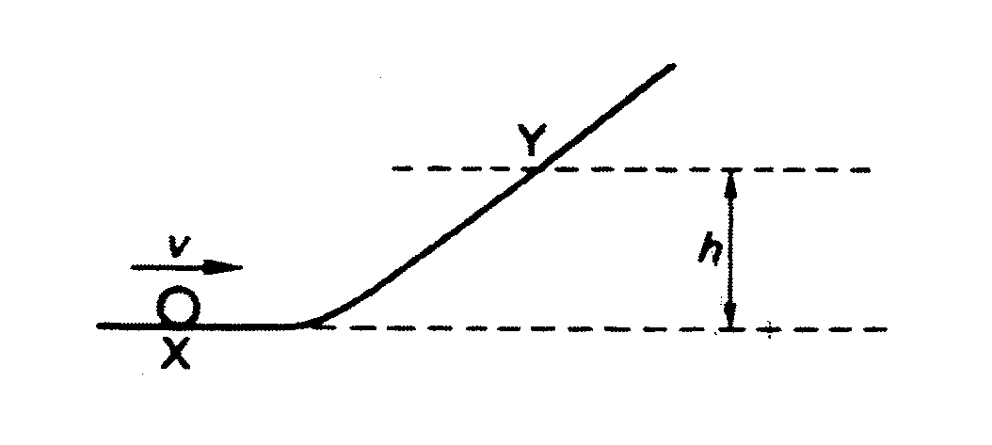

A second object of mass 2m passes X with a velocity of v/2. To what height will the second object rise?

A. h/2 B. h/4 C. h/8 D. h/16
18. A power station has an efficiency of 50 % and generates 1000 MW of
electrical power. What is the input power and the wasted power?

 | input power / MW | wasted power / MW
A | 2000 | 1000
B | 2500 | 1000
C | 2500 | 1500
D | 2000 | 1500

19. A constant pressure of 3.0 x 10⁴ Pa is exerted on a piston, of area 2.5 x 10⁻³ m²,
which encloses a gas as shown in the diagram.
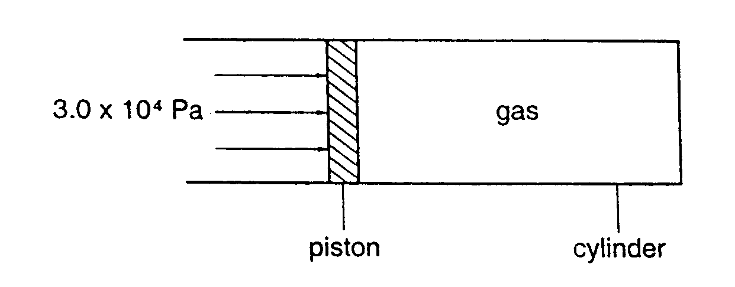
Friction between the piston and cylinder can be ignored

The gas is heated, the temperature rises and this causes the piston to move 4.0 mm.

How much work is done on or by the gas during this movement?

A. work done on the gas = 0.60 J

B. work done by the gas = 0.60 J

C. work done by the gas = 0.30 J

D. work done on the gas = 0.30 J
[Turn Over
20. A 75 kg traffic light is held stationary midway between two supports, as shown in diagram below.
80⁰
80⁰
cord

What is the tension in the cord?

A. 370 N B. 740 N C. 2100 N D. 4200 N

21. The diagram below represents the displacement of a particle caused by a progressive wave travelling at a speed of 5.0 kms⁻¹.
displacement/μm
time/μs
+ 2
- 2
O
10
20
30
40

What is the frequency of vibration of the particle?
A. 2.5 kHz B. 5.0 kHz C. 25 kHz D. 50 kHz

22. Progressive waves of frequency 300 Hz are superimposed to produce a system of stationary waves in which adjacent nodes are 1.5 m apart. What is the speed of the progressive waves?
A. 200 ms⁻¹ B. 450 ms⁻¹ C. 900 ms⁻¹ D. 1800 ms⁻¹

23. Physical properties shared by both radio waves and sound waves are:
    - both can be polarized
    - both are electromagnetic waves
    - both can be diffracted
- if all correct.
- if 1 and 2 correct.
- if 2 and 3 correct.
- if only 3 is correct.

24. A progressive simple harmonic wave has a frequency of 150Hz and a velocity of 30ms⁻¹. The phase difference between two vibrating points which are 10cm apart is
- 0 rad C. π rad
- π / 2 rad D. 2π rad

25. Under which conditions will the bright fringes of a double-slit light interference pattern be farthest apart?
distance between slits distance from slits to screen wavelength of source
A. small large short
B. small large long
C. large small short
D. large small long

26. The rulings on a diffraction grating are 6000 lines cm⁻¹. What is the highest order of spectrum that can be viewed with light of wavelength 500nm?
- 2nd order
- 3rd order
- 4th order
- 5th order

[Turn Over

27. A tuning fork of a certain frequency is sounded over the open of a resonance tube, which is closed at the other end. Resonance is observed when the tube is 0.20m. The next resonance will be observed when the tube has a length of
- 0.30m
- 0.40m
- 0.43m
- 0.60m

28. In the direction indicated by an electric field line,
- the electric field strength must increase.
- the electric field strength must decrease.
- the potential must increase.
- the potential must decrease.

29. Which diagram shows the electric field pattern of an isolated negative point charge?

-
-
−
A. B. C. D.
+
+

30. The current in a component is increased uniformly from 20mA to 80 mA over a time period of 4.0 s. What is the charge that flows during this time?

A. 240 mC B. 200 mC C. 120 mC D. 60 mC

31. A charge of 3C experiences a force of 3000N when it is moved in a uniform electric field, E. What is the potential difference between two points X and Y separated by a distance of 1cm
• X

• Y
E
- 0V
- 10V
- 1000V
- 9000V

32. An electron enters a region a space where there is a uniform electric field E as shown below.

path of electron
E

Initially, the electron is moving parallel to and in the direction of the electric field. What is the subsequent path and change of speed of the electron?

path of electron change of speed of electron
A. linear decreases
B. linear increases
C. parabolic decreases
D. parabolic increases

[Turn Over
33. The graph below shows the variation with potential difference V of the current I in the component X,Y and Z.
Z

Y
X
I
V

Which of the following correctly identifies the components?
 | metallic conductor at constant temperature | semiconductor diode | filament lamp
A | X | Z | Y
B | Y | X | Z
C | Y | Z | X
D | Z | Y | X

- A cell of e.m.f. E delivers a charge Q to an external circuit. Which statement is correct?

A. The energy dissipation in the external circuit is EQ
B. The energy dissipation within the cell is EQ
C. The external resistance is EQ
D. The total energy dissipation in the cell and the external circuit is EQ
35. Each of Kirchhoff's laws is linked to the conservation of a physical quantity. What physical quantity is assumed to be conserved in the formulation of Kirchhoff's first and second law?

Kirchhoff's first law Kirchhoff's second law

A. energy charge
B. energy momentum
C. charge energy
D. momentum energy

36. Three resistors are connected as shown in Fig. Below and the points x and y are connected to a source of direct current.
X
I₁
R₁
R₂
R₃
I₂
I₃
Y

The ratio I₁/I₃ is
- (R₃ + R₁)/R₁
- (R₂ + R₁)/R₁
- dependent on the internal resistance of the source
- independent of R₁

37. Two resistors of resistance 200 kΩ and 1MΩ form a potential divider with outer junctions maintained at potentials of +3 V and –15 V. What is the potential at X?
-15V
+3V
200 kΩ
1 MΩ
X

A +1 V B 0 V C –0.6 V D – 12 V
[Turn Over

38. As a result of a number of successive decay processes in a radioactive series the nucleon number decreases by 4 while the proton number is unchanged. The particles emitted are:
- 1 alpha and 1 beta particle
- 1 alpha and 2 beta particles
- 2 alpha and 1 beta particle
- 2 alpha and 2 beta particles

39. The deviation of α particles by thin metal foils through angles that range from Oº to 180º can be explained by:
- scattering from free electrons
- scattering from bound electrons
- diffuse reflection from the metal surface
- scattering from small but heavy regions of positive charge

40. A high energy α – particle collides with a 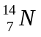 nucleus to produce a 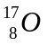nucleus. What could be the other products of this collision?
- a γ – photon alone
- a γ – photon and a β – particle
- a γ – photon and a neutron
D. a γ – photon and a proton

